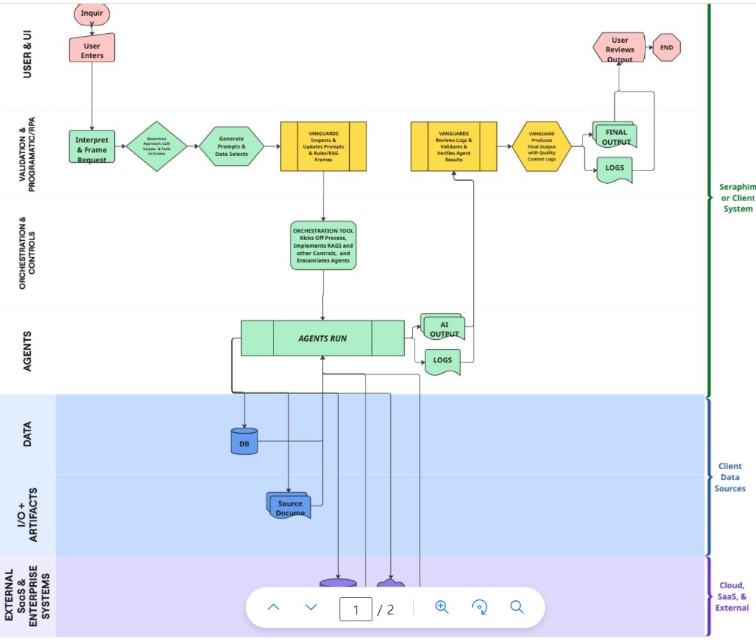

**Key Sections & Flow (Top to Bottom)**

**1. User & UI**

* **"User Enters" & "Inquiry"**: Entry point for a human initiating a request.
* **"User Reviews Output" → "End"**: Concludes with user evaluation of the final result.

**2. Validation & Programmatic/RPA**

* **Interpret & Frame Request**: Parses user input, likely involving NLP and basic validation.
* **Generate Prompts & Data Selects**: Dynamically constructs context-specific prompts and identifies which data to use.
* **VANGUARDS**: Modules performing rule enforcement, frame creation, and prompt finalization.
* **Review & Validation Step**: VANGUARDS again verify results and validate agent output.

**3. Orchestration & Controls**

* **Orchestration Tool**:
  + Kicks off processing.
  + Implements RAGs (Retrieval-Augmented Generation) or other guardrails.
  + Instantiates agents for execution.

**4. Agents Layer**

* **AGENTS RUN**: Core agent execution happens here. Likely includes reasoning agents, planners, or task executors.
* **AI OUTPUT & LOGS**: Agents produce output and logs which flow upward for review and downward for traceability.

**5. Data Layer**

* **DB & Source Document Access**: Agent pulls structured data from a database and unstructured content from source docs.

**6. I/O + Artifacts**

* This layer mediates between external documents and internal components, ensuring proper format or tokenization.

**7. External Enterprise Systems**

* **Cloud / SaaS / External**: Represents integration with 3rd-party APIs, external databases, SaaS products, or client infrastructure.

**Interpretation and Control Loops**

* **Feedback loop from Logs → VANGUARDS → FINAL OUTPUT**:
  + Introduces a **quality control layer** where outputs are validated and either approved or corrected.
* **Direct connection between AI OUTPUT and User**: Final result is user-facing, but only after QC from VANGUARDS.
* **Logging appears in 3 places**: after agent execution, final output, and user review—showing a strong emphasis on **auditability and explainability**.

**Strengths of the Design**

* **Clear Separation of Responsibilities**: Layers for UI, control, execution, and data are well-separated.
* **Emphasis on Validation**: Repeated validation checkpoints reduce hallucinations or unsafe outputs.
* **Scalability**: Modular—new agents, validation rules, or external data sources can be added without breaking flow.
* **Compliance Ready**: With logging and validation layers, this system is built with compliance and audit-readiness in mind.

**Areas for Improvement**

1. **Missing Agent Decision Layer**: Where is task selection, prioritization, or routing logic defined? The orchestration box is generic.
2. **VANGUARD Role is Overloaded**: They appear 3 times—this may benefit from splitting into named subcomponents (e.g., Validator, QA Filter, PromptBuilder).
3. **No Retry/Error Pathways**: What happens if validation fails? Currently looks linear and successful by default.
4. **No Explicit Security Layer**: There's no visual treatment of auth, access control, or secure handling of inputs/outputs.
5. **External Systems Block is Underutilized**: It could show specific types (e.g., Salesforce, S3, ElasticSearch) or interaction patterns (REST, batch, streaming).

**Suggestions**

* Add a **Task Planner or Queue Manager** between Orchestration and Agents.
* Show **conditional paths** for rejected outputs or flagged inputs.
* Introduce a **security layer or annotations** on sensitive data flows (especially from/to External Systems).
* Consider separating **data ingestion pipelines** for structured and unstructured data.
* Visually code VANGUARDS as a “class” with different responsibilities.